Nieuwegein, 09/11/2022

NON-GMO DELCARATION
Puijk Plant B.V. states that all varieties that are currently for sale or testing, have been issued and in circulation allowed, have been devoleped through traditional breeding work, without using genetic modification techniques.
If we in the future varieties in test or in the circulation, which can be regarded as genetically modified Varieties (GMO's, Genetic Modified Organisms), then we will publish.

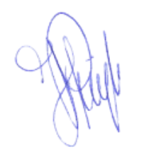
Kind regards,
Hans Puijk
Puijk Plant B.V.

